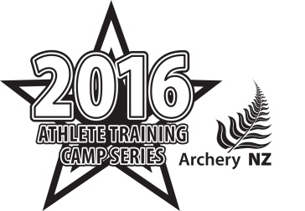
ANZ Athlete Training Camp
Auckland –22-24 July 2016
Coach Registration Form

Entries are due 5pm Friday 1st July – please send entries and any enquiries to andrew@russellnz.net

Your Personal Information
Name
Date of Birth
Email
Phone Number | Home: Mob:
Address
Shirt Size (Men) | XS / S / M / L / XL / XXL (adult sizes)
Shirt Size (Women) | 6 / 8 / 10 / 12 / 14 / 16 / 18 / 20 / 22 / 24

Under 18yo Only – Parent/Guardian Information
Name
Phone | Home: Mob:
Email

Your Coaching Profile
ANZ Club
ANZ Membership #
# of years Coaching
ANZ Coach Level | Year achieved:
Other Coaching Qualifications
Current Students (please also list coaching programs you contribute to)
Proudest Coaching moment

Are you an Archer as well? YES / NO
Bow Type | Compound / Recurve / Crossbow / Longbow
Bow Brand/model
Poundage
Draw length
Arr. brand/spine
Arrow Length
Tab/Release

Goals / Plans for Professional Development
Goals

Consents

I consent to ANZ collecting the details provided above, retaining and using those details and disclosing them along with scores, results, photographs & video from the event to bodies associated with archery, and the news media for the purpose of involving me in ANZ's activities now and in the future. I acknowledge my right to have access to this information. The consent is given in accordance with the Privacy Act 1993.

Coach Signature: Date:

Parent/Guardian Signature: Date:

Parents/Guardians Accommodation and Meal Request

The following parents or guardians require accommodation and meals:

Camp Fees

Fees are dependent on final numbers attending, and are anticipated to be in the order of the following:

Attendee Type | Cost
Athlete | $250
Coach | $100

Camp fees will be invoiced to applicants, and must be paid in full to reserve your spot at the camp. Priority will go to order of applicants.

No refunds will be available, as fees will be paid by ANZ to secure the venue and accommodation.

