Youth Awards
Claim guidelines

General Information
Youth badges and pins can be achieved at any major outdoor tournament where a junior has competed at their relevant World Archery (WA) or Youth distance or above. The postal round badge system can also be claimed through club shoots.
Badges and pins may be claimed as long as the archer shoots in their correct age group or a higher age group at a registered major tournament or national event.
Costs
Each badge and pin costs $10.
The postal round badge system is the only exception, with the starter badge and ribbon costing $10 and each bar $5.
Payment can be paid in cash, cheque, or via online banking (Kiwibank 38-9015-0468141-01 include ‘Surname’ and ‘Youth Pins’ in payment details)

Claiming
Each claim form must be accompanied by an original or copy of the scoresheet. The claim form should be filled out correctly, and more than one claim can be made per claim form. The scoresheet must be signed by all parties, with perfects clearly outlined by the judge, and the claims entered into the claim box. If the scoresheet does not have a claim box the claims should be written somewhere on the scoresheet. The exception is the postal badge system where the claim form only needs to be signed by the club Youth coordinator.
All badges can be claimed only once, unless claiming for a broken badge. In this case the badge should either be posted back or a photo should be sent to the Youth Awards Registrar. A replacement will be sent. If badges are lost (or stolen) an archer is able to purchase new replacement badges or pins.
Those shooting in the Cadet and Junior divisions are also eligible to claim WA badges and pins.
Claims are to be sent to: youthawards@archerynz.co.nz

Awards
YOUTH OVERALL SCORE BADGES- 1440 ROUND  - Only one 1440 badge may be claimed per scoresheet.  - These badges can be claimed in any order. | 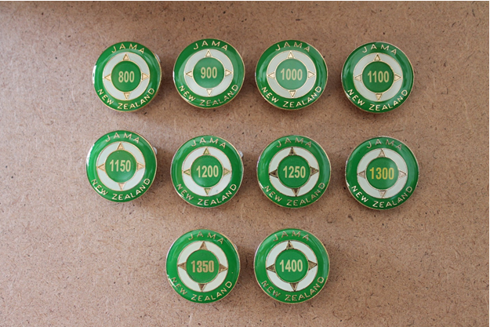
YOUTH OVERALL SCORE BADGES - 720 ROUND  - Only one 720 badge may be claimed per scoresheet.  - These badges may be claimed in any order. | 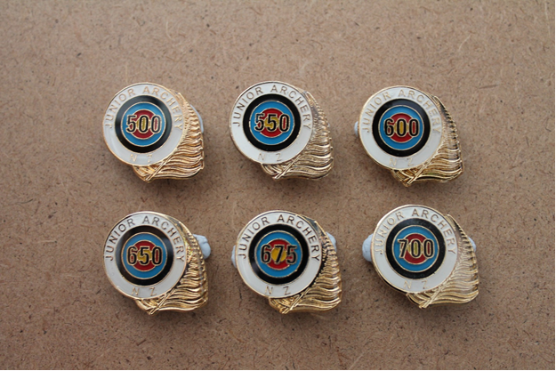
YOUTH OVERALL SCORE BADGES- INDOOR ROUNDS  The total score badges can be claimed from any major indoor tournament where an 18m Round or a 25m Round are shot.  - Only one Indoor Archery badge may be claimed per scoresheet.  - These badges can be claimed in any order. | 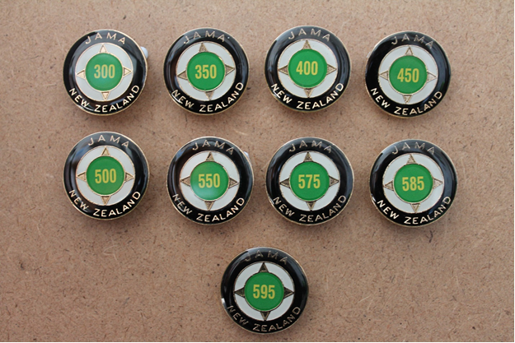
YOUTH POSTAL ROUND  These badges may be claimed when a shooter achieves the outlined pinscore from that months Youth Postal Round. They can be claimed from major tournaments and club shoots and must be signed off by the club Youth coordinator.  - Only one pinscore bar can be claimed per month.  - Only one pinscore is required per bar.  - Bars can only be claimed once. | 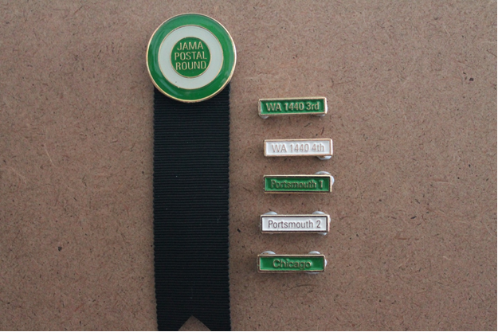
YOUTH OUTDOOR PERFECT PINS  Youth outdoor perfect pins can be claimed if all 6 arrows shot in one end are in the gold or, when 3 arrow ends are shot for either of the 2 closest distances, if all 3 arrows shot in one end are in the 10 zone.  - One perfect may be claimed per distance, and more than one perfect can be claimed per scoresheet.  - These pins can be claimed in any order. | 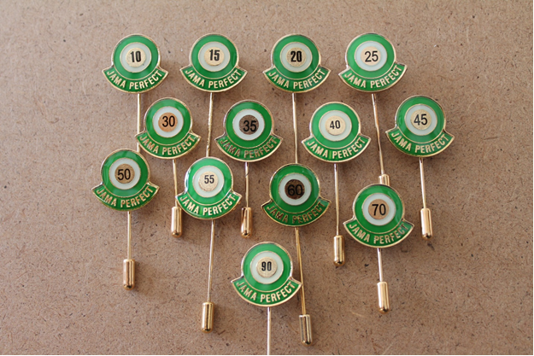
YOUTH INDOOR PERFECT PINS  JAMA indoor perfect pins can be claimed if all 3 arrows shot in one end are in the 10 zone.  - One perfect may be claimed per distance, and more than one perfect can be claimed per scoresheet.  - These pins can be claimed in any order. | 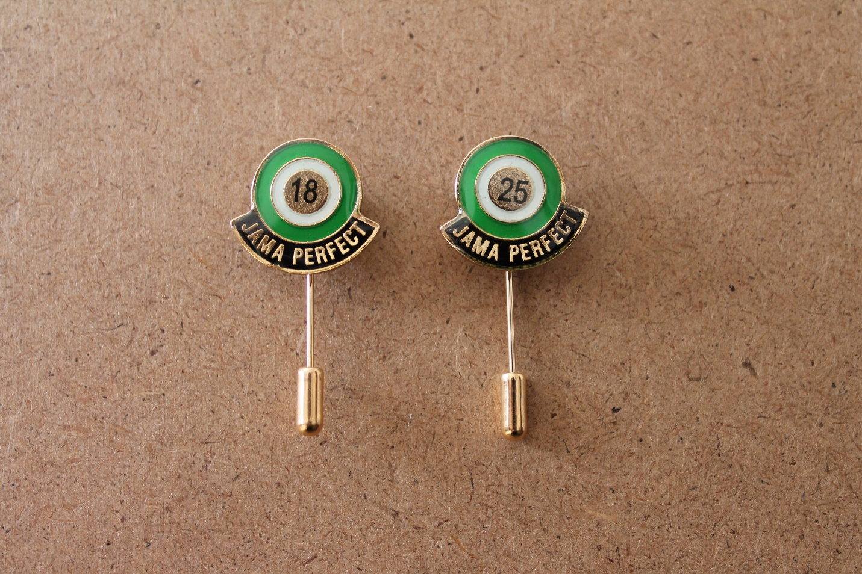
Note: The term JAMA was replaced by Youth in late 2017. Existing stocks of JAMA pins and badges will be used before new ones are purchased, and at this time, the term JAMA will be changed.

