TidyHQ Membership Database
Go to:
https://archery-nz.tidyhq.com/
This will bring up the Archery NZ database. Hit ‘Login’
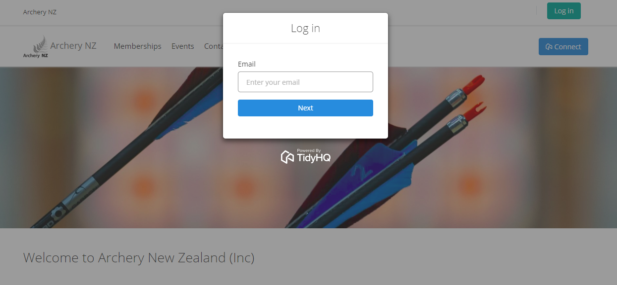
Type in your email address (everyone needs to have a separate email address). It will tell you it does not recognise your email and ask if you would like to ‘create and account’ click on that.
You will be asked to enter your name and agree to the terms & conditions – tick this and hit ‘create account’
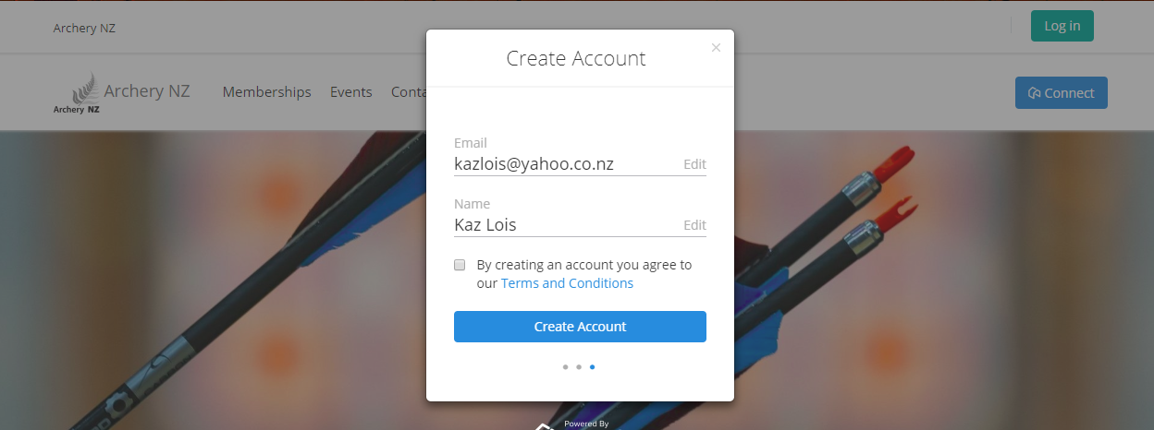

You will see a message telling you ‘account created’ and an email will be sent to that email address.
On your email click ‘set password’ and it will take you back to TidyHQ. Passwords need to be a minimum of 6 characters long.
Hit ‘Update’
Then you are here:
Click on Archery NZ
Then click on the initials top right of screen to set up your contact profile
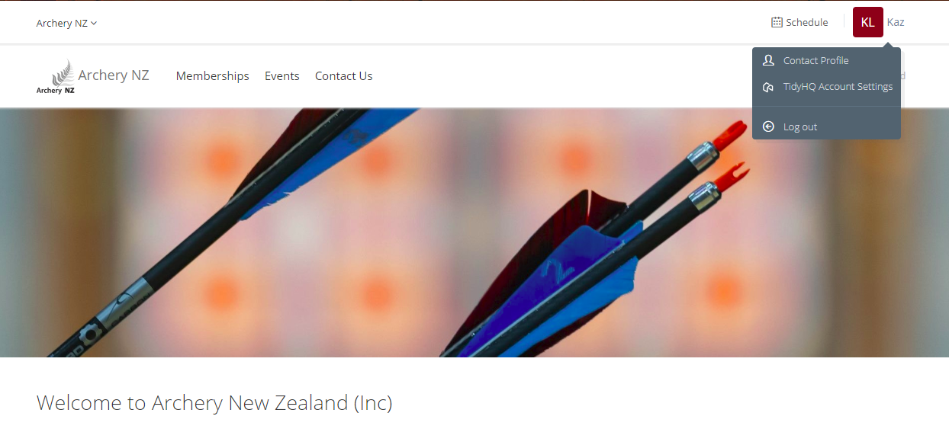
Fill in as much detail as possible, you will be allocated a membership number later. Don’t worry about the club & district info but please put which school you are representing in the Archery in Schools, school association:

An invoice for the $10 annual membership will be emailed out to you. You can either pay via bank transfer or direct deposit into the Archery NZ Account – please put ‘AIS’ as your reference, or you can pay via credit/debit card by selecting the ‘pay now’ option on the invoice.

