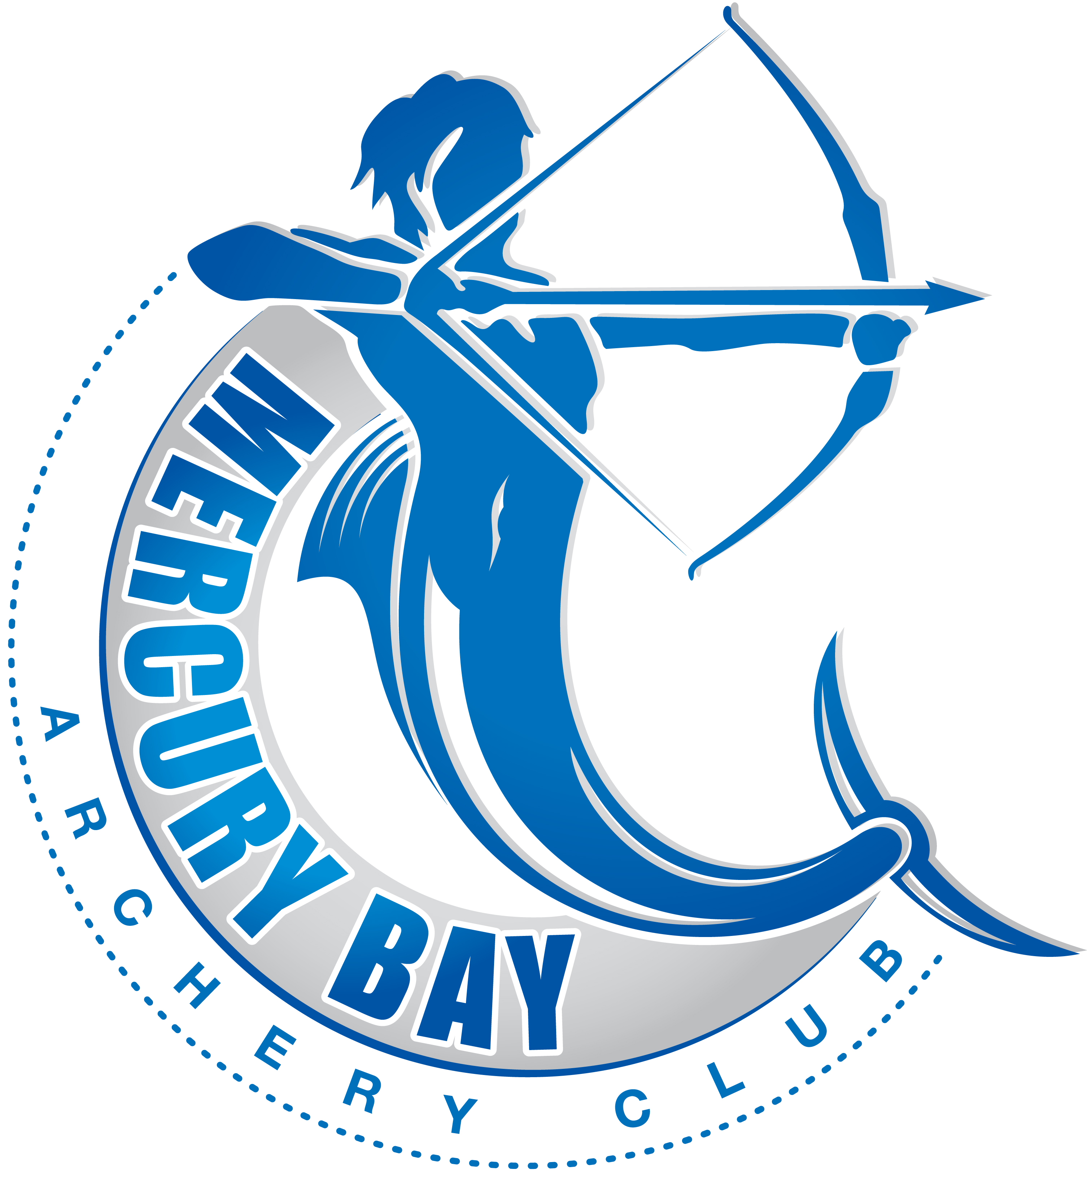
SITE HAZARD REGISTER – CLUB
MBAC
186 South Highway Moewai, Whitianga

Known Site Hazards

Identified Hazard |  |  | Action Taken
Un-level ground | Eliminate
Tripping | Isolate |  | Drainage channel by entrance gate. Club Members will be made aware of this hazard. Hazard to be sprayed with Dazzel.
 | Minimise | ✓
Marquee/Gazebo Guide ropes & pegs | Eliminate
Tripping | Isolate |  | Pegs to be flush with ground or capped with high vis toggle.
 | Minimise | ✓ | Guide ropes to have a coloured marker tied on for visual recognition.
 | Eliminate
 | Isolate
 | Minimise
 | Eliminate
 | Isolate
 | Minimise
 | Eliminate
 | Isolate
 | Minimise

